**Topic:** Sir Isaac Newton

**Notes on Topic:**

**A Mind Unleashed:**

Newton was born prematurely on Christmas day in 1642 to his widowed mother, and against all odds survived the harsh winter and live to the astonishing age of 84  
When Newton’s mother remarried, the new husband was not wanting a three year old son, so Newton was left to live with his grandmother  
Newton got a traditional education, studying the works of Latin and Greek scholars  
He kept mostly to himself, and took to making things to occupy his time; he would make windmills that turned from a mouse running, he made sundials, attaching lanterns that were lit to a high flying kite during dark spring nights

Newton headed to college in Cambridge at age 19, he studied at Trinity College, an institution open for 400 years at this point, known for the King James translation of the Bible and the masterpiece of King’s College Chapel

Newton started his studies in Latin Literature and Aristotelian philosophy and quickly lost interest in his studies due to him seeing himself as brighter than his tutors and he had no one who cared whether he did or did not focus on his studies

While Newton’s peers veered from their studies and turned to the pubs, Newton fell deep into reading and contemplation  
Newton would walk around in such deep contemplation that he would forget to eat and sleep when faced with an especially intriguing problem -- reminiscent of Archimedes

Newton also held onto a lot of guilt, which was apparent by the book of sins that he kept

He often conducted experiments on the nature of light, color and vision; he once stared at the sun for an extended period of time and then recorded the spots that affective his vision for the days to come

Newton’s first time reading *Elements* he found most of the information trivial and self-evident

He not only read the works of the ancient Greeks, but also dove into the works of Descartes, he would read *La Geometrie* and would find himself stumped with some of the material, so he would begin the book again, he repeated this diving deeper and deeper with each read, teaching himself and looking deeply at it each time without a tutor

Newton had a hard time finding anyone who qualified to help him with his studies; that is, until Isaac Barrow, occupant of the prestigious Lucasian Chair of Mathematics

Through reading, and the guidance of what to read from Barrow, Newton went from a skilled scientific and mathematical scholar to being up to date with every discovery made in these disciplines

Having caught up with all the discoveries of the time, he was ready to stumble through uncharted territory  
  
By 1664, Newton was promoted to a scholar at Trinity and was offered four year financial support to earn his Master’s degree

Newton was now free to study what interested him most, and spend his days in deep contemplation like he preferred, and use his amazing power of concentration

Newton’s explanation for how he solved his wonderful problems, “by thinking on them continuously” // and he really meant continuously, until he saw right through them at every angle

The next two years were the most productive of any thinker  
Most of which was spent in Cambridge, and the rest spent in Woolsthorpe due to the university closing from the dreaded plague  
  
Early in 1665 he discovered the generalized binomial theorem  
He came upon his “method of fluxions” today known as differential calculus  
And in 1666 he devised the inverse method of fluxions, today known as integral calculus  
He then formulated his theory of colors   
  
He follows with his embryonic theory of universal gravitation  
The two plagued years 1665-1666 are known as Newton’s “wonderful years”, legend has it all his theories emerged in these two years, and his later years he spent refining and editing them, During these two years he was nothing more than an anonymous university student  
  
  
**Newton’s Binomial Theorem:**  
His first great mathematical discovery  
Newton did not furnish a complete proof, so theorem is loosely used  
The binomial theorem deals with the expansion of binomial equations to a high, nth degree  
The Chinese mathematician, Yang Hui knew this secret in the 13th century, but was unknown in Europe until relatively recent times

Viete ran through binomial powers in his *In Artem*

And Pascal was the first to dive deep into binomial expansion and is credited with Pascal’s Triangle, an easy pattern to calculate the coefficients of a binomial expansion of high degrees

The link between Pascal’s triangle and Newton’s theorem is immediately recognizable   
Newton wanted to be able to generate the coefficients more efficiently without running through the pattern of Pascal  
Newton felt the need to come up with a general formula that works for rational, or negative powers as well  
Newton’s first binomial expansion:

**insert expansion here Pp 167

${(P+PQ)}^{\frac{m}{n}}=P^{\frac{m}{n}}+\frac{m}{n}AQ+\frac{m-n}{2n}BQ+\frac{m-2n}{3n}CQ+\frac{m-3n}{4n}DQ+...$

**

This looks unfamiliar and perplexing, but after a bit of explanation, it starts to look familiar,

**insert explanation here Pp 168**

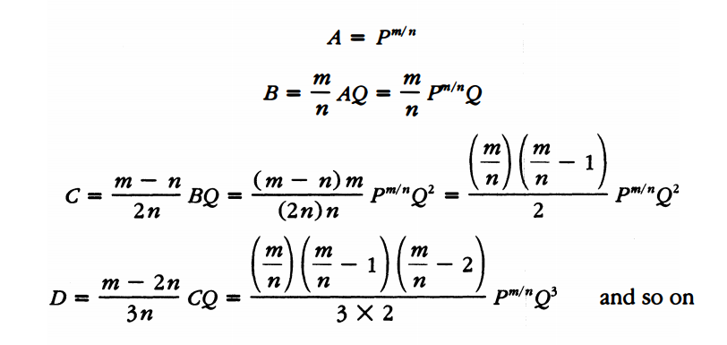

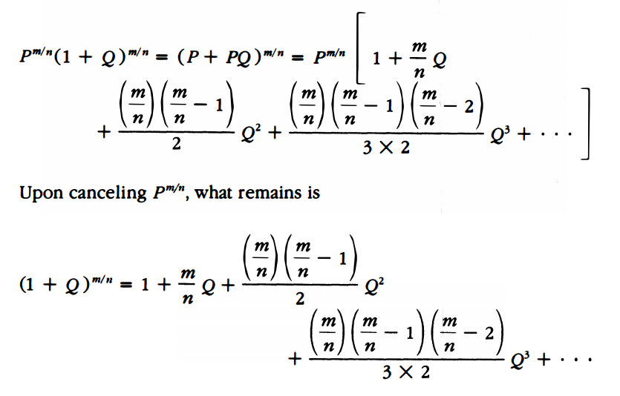

**In Class Examples:**

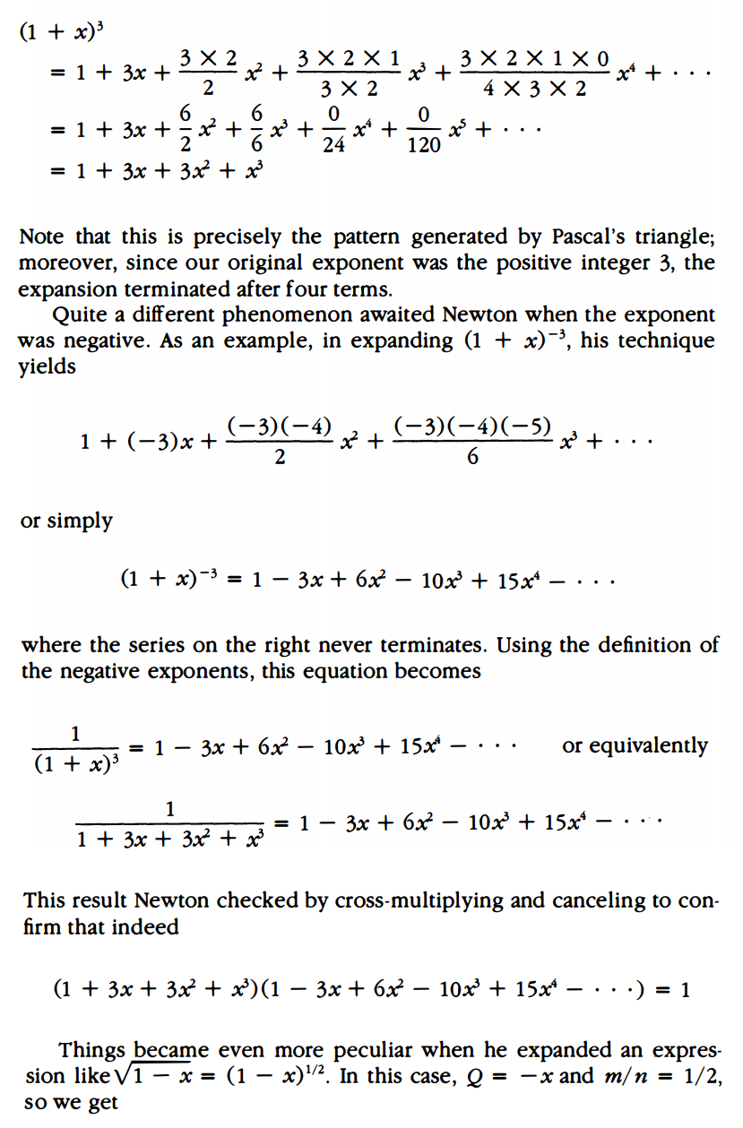

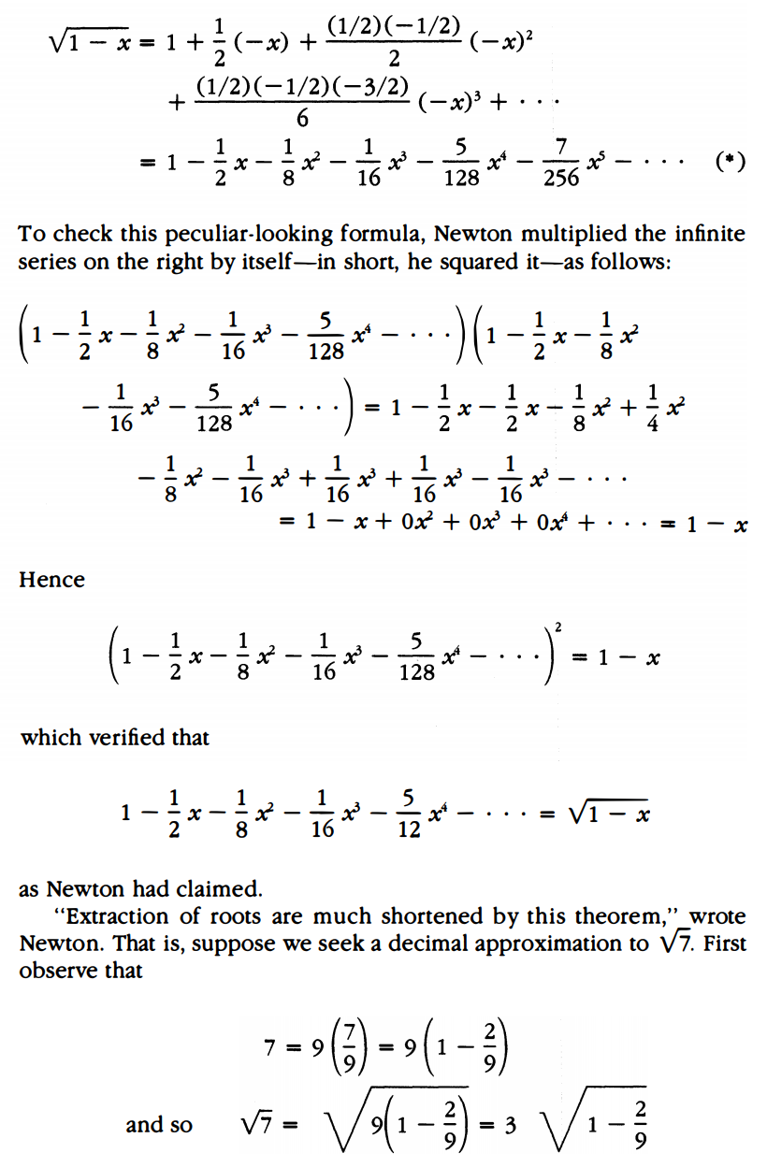  
****Finish the expansion in class $\sqrt{7}≈3(1-\frac{1}{9}-\frac{1}{162}-\frac{1}{1458}-\frac{5}{52488}-\frac{7}{472392}) = 2.64576$

****

Which is only off by 0.00001, but as we starting expanding more and more terms, the accuracy would be nearly identical

Newton’s binomial theorem tells us which fractions to use, and generates them in a mechanical fashion   
  
The binomial theorem is one of two theorems used in the proof of the upcoming great theorem.

In 1669 Newton wrote his first treatise on his fluxion ideas, and circulated it to a few mathematicians including Barrow

*Let the Base AB of any curve AD have BD for it’s perpendicular Ordinate; and call AB=x and BD=y and let a, b, c, etc be given Quantities, and m and n whole numbers. Then,*

*Rule 1: If $ax^{\frac{m}{n}}=y$, it shall be $\frac{an}{m+n}x^{\frac{m+n}{n}}=Area ABD$*

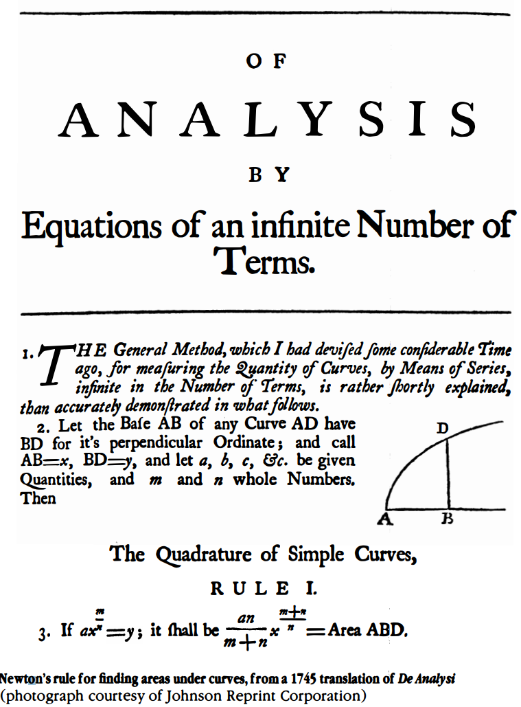  
  
Using the binomial expansion and finding the area under a curve, Newton would use these tools to again try and approximate the value of pi

**Additional Suggested Reading**: None

**Assignment:** Homework 6 Problems: 92, 94